# Revision history

**Version:** 0.1

**Date of creation:** 02/09/2021

**Team code: PRJ-CB05 3**

**Team name:** RASH

**Team members:**

* Stefan Popescu
* Anna Kowalewska
* Hristo Tanchev
* Rawan Alahabsi

Project plan

semester 2 project mediabazaar

Ania Kowalewska, Stefan Popescu, Hristo tanchev, rawan Alalhabsi

2021

|  |  |  |  |
| --- | --- | --- | --- |
| Version / Status | Description | Author | Date |
| 0.1 | First draft of the Project Plan, containing mostly everything for the completion of the project | Ania Kowalewska, Stefan Popescu, Rawan Alalhabsi, Hristo Tanchev | 02/09/2021 |

Contents

Revision history 1

About us 3

Roles 3

Client 4

Current situation 5

Problem description 6

Project goal 7

Deliverables 8

Non-deliverables 9

Constraints 10

Phasing 11

# About us

**Team code:** PRJ-CB05 3

**Team members:**

* Stefan Popescu (s.popescu@student.fontys.nl)
* Anna Kowalewska (a. kowalewska@student.fontys.nl)
* Hristo Tanchev (h.tanchev@student.fontys.nl)
* Rawan Alalhabsi (r.alalhabsi@student.fontys.nl)

RASH is a group of IT students from Fontys University of Applied Sciences in Eindhoven. We develop software applications on demand to simplify the work activities of companies and to solve issues where needed within the work environment.

## Roles

This team is made by a group of four Fontys University students who are aiming to help Media Bazaar company to manage their administration issues by using software solution, willing to ease their work in administration system.

1.1. Our Rule

Every week the role of the leader of the team will be switched to another member of the group, where the leader of the group is the one who is responsible of the progress that will be made in his week and for making meetings with the tutor or the client.

The order of the team leader:

1. Stefan Popescu

2. Rawan Alhabsi

3. Hristo Tanchev

4. Anna Kowalewska

# Client

A new company named “MediaBazaar” wants to open its very first shop in Eindhoven. MediaBazaar is a warehouse which sells all kinds of products. However, they are still unsure how the store should be managed. Therefore, they are in need for a group of software developers to develop an application wherein the store will be managed. To do this correctly, clear requirements are needed. In the upcoming weeks, client meetings will be held to specify the different requirements of the application.

**Contact details of new client:**

* Lara Rojas, John J.G.
* **j.lararojas@fontys.nl**
* 0622428741

# Current situation

At this moment, MediaBazaar does not own a management system which is needed to run a local office here in Eindhoven. The system should be able to manage its employee’s data, departments, and products. Moreover, it needs to be able to automatically assign employee(s) to a specific shift. Also, statistics should be available for the management. MediaBazaar contacted multiple companies including us to create that management system. These companies are all working on this project. Eventually, the best one will be chosen and implemented by MediaBazaar.

**Current management methods:**

1. Work shifts are manually assigned to employees in excel sheets
2. Manual attendance checking by calling employee names during a live meeting
3. Manual stocks management in which you must count the number of products yourself
4. Data of employees is being stored on paper
5. Data of departments is being stored on paper

# Problem description

MediaBazaar is at this moment unable to manage its employees, departments and products. Our client explained what kind of issues they deal with regarding the employees’ administrative system, workload and shift management. On top of that, there are no statistics available to determine which product has been sold the most or employee was less available. Based on those statistics, the company can make important decisions.

# Project goal

Looking at this project, the main goal is to digitalize the work environment of MediaBazaar. This will allow the employees of the company to focus and put more effort into more meaningful tasks. Also, with the new system, employees gain more trust in the company since their work activities will be simplified and that all while having a fair distribution of work shifts. Moreover, statistics are given of which employee works well or which product sells the most. Based on those statistics the management can make some important decisions.

# Deliverables

It is good to know up front which products will be delivered during a project. The project is divided in 3 phases which last 6 weeks each. The first phase is via the waterfall method and the second and third phase via the agile method. The second and third phase also called the iterative phase will have four iterations in total. These are the deliverables regarding the first phase of management system project:

1. A project plan
2. An URS document
3. A first version of the C# Windows Form Application of a Management system (includes employee tab, department tab, shift tab)
4. A test document

These are the deliverables regarding the first iteration of the second phase:

1. A first version of a website where employees of the company can log in to see their personal information and schedule
2. A second version of the C# Windows Form Application of a Management system (includes scheduling tab, department tab, employee tab, shift tab)
3. A test document

# Non-deliverables

However, it is also good to know up front which products will **NOT** be delivered during a project. These are the non-deliverables regarding the management system project:

1. Continuous technical support for the application will not be offered
2. The hardware features are out of scope for this project, only the software

# Constraints

When working on a project there are always some constraints you have to take into account to keep the client satisfied. These are the constraints regarding the management system project:

1. The application should be coded with C#, ASP.NET & Javascript only, other code languages are out of scope for this project.
2. The application will be built in 3 phases and should be finished on the 14th of June for MediaBazaar to open its shop on time. The end date of the first phase is the 29th of March and the end date of the second phase is the 5th of May.
3. Due to the global pandemic, meetings need be online via MS Teams instead of in person.

# Phasing

This project is divided in 3 large phases. For now it is good to only focus on the first phase of the project which will be described here. Firstly, the documentation part that will take place in the first two weeks. During this phase we are creating a plan about what, when and for whom we are going to develop the product.

By doing this we are creating a URS, in this documentation we are specifying in steps in which way the user is going to interact with the GUI.

Secondly, we are going to create a logo and come up with a name that suits our team.

Lastly, an interview with the client will take place during this phase, which is the most important part.

During this interview we are going to ask the client a couple of questions which will give us an idea how we are going to start our project and what must be developed.

The last weeks of the first phase, we will start with the implementation. We are going to analyse the feedback that the tutor provides us. This feedback will be implemented in our coding process to maintain continuous improvement.

In the first iteration of the second phase we are going to create a website with php where employees of MediaBazaar can login to see their schedule and personal information. Moreover, the management application will be extended with more requirements. These requirements will be discussed with the client during the client meeting. Because of those new requirements, the URS needs to be updated as well.

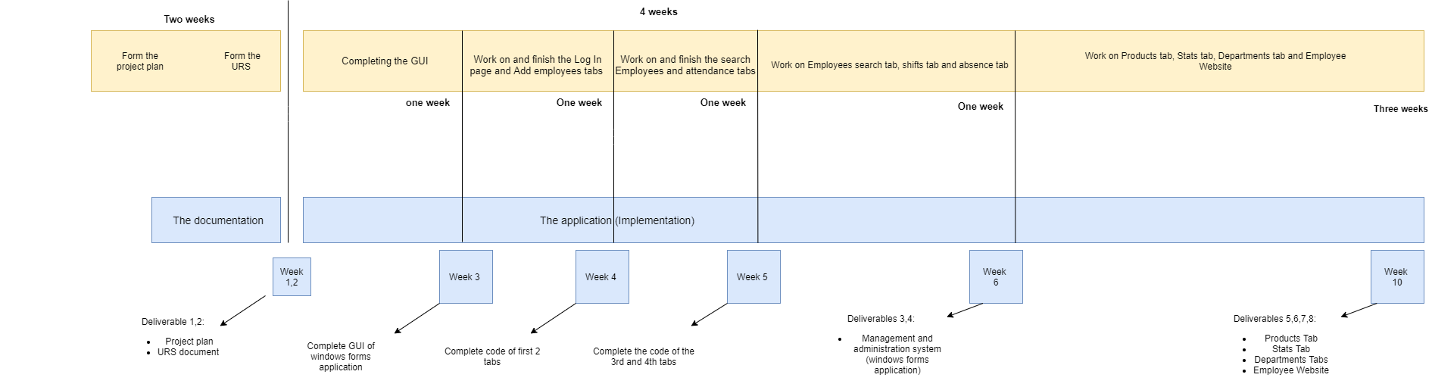

Fig. 1. Phases Diagram